**Configuring IIS Redirection from HTTP to HTTPS**

**Please note**, this article assumes that Goliath Performance Monitor or Goliath Application Availability Monitor is/are the only application(s) being hosted by the locally installed Internet Information Services instance. Performing the following tasks may break any other installed applications.

If an IIS-enabled version of Goliath Performance Monitor is installed, the Web UI for GPM will default to HTTPS / TCP Port 443. When accessing port 80, the default IIS page will be displayed:



Launch the Internet Information Services Management console on the GPM / GAAM Server by searching for "Internet Information Services Manager" in the Start Menu:

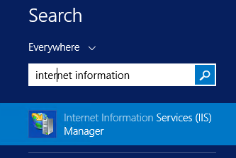

Or locate "Internet Information Services Manager" under Start / Administrative Tools:

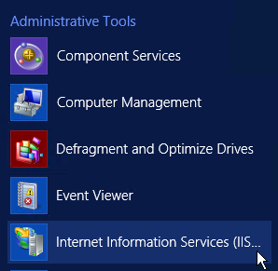

In a default instance of GPM or GAAM, there will be two sites configured in IIS, one is "GoliathWeb" (the Goliath Web UI) and the other is "Default Web Site" configured when IIS is installed/activated on a Windows Server.

GPM Web UI Site bound to TCP Port 443 / HTTPS:

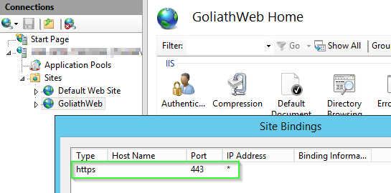

Default Web Site bound to TCP Port 80 / HTTP: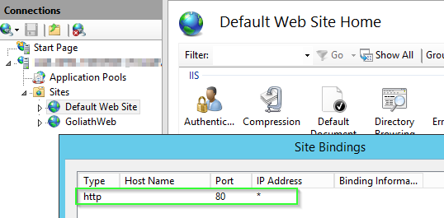

The below modifications will be performed on the "Default Web Site" in order to forward traffic to the "GoliathWeb" site.

First, rename the existing iisstart.htm found (by default) in C:\InetPub\WWWRoot to iisstart_old.htm

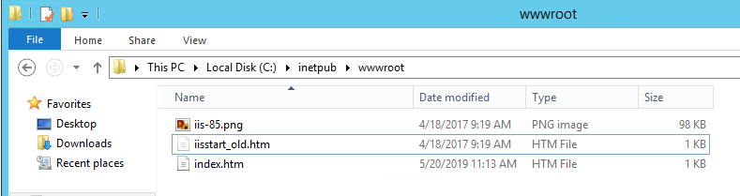

Next, create a new file called index.htm with the following contents:

<html>  
<head><title>Redirecting...</title></head>  
<script language="JavaScript">  
function redirectHttpToHttps()  
{  
 var httpURL= window.location.hostname + window.location.pathname + window.location.search;  
 var httpsURL= "https://" + httpURL;  
 window.location = httpsURL;  
}  
redirectHttpToHttps();  
</script>  
<body>  
</body>  
</html>

All requests on HTTP to the "Default Web Site" will now be redirected to the "GoliathWeb" site on HTTPS.